|  |
| --- |
| Student Name: Hasan Alhwietat  Student ID: 20120098  Section #:  **Video prototype: https://youtu.be/8Dvjkoai3rs** |

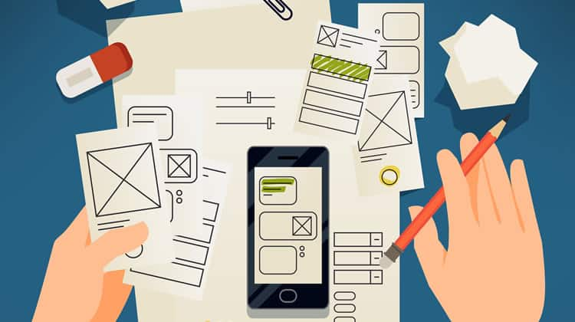

Prototyping

Assignmnet 1

Spring 2022

Contents

**1-** **Different Forms of prototyping** 2

1.1 Discuss the different forms of prototyping, their purpose, their advantages and disadvantages, their testing outcomes. 2

1.2 Review the Standard Prototyping tools by providing a brief explanation about each tool and how they can be used in identifying and testing user requirements effectively. 2

**2-** **Review different end user categorizations, classifications and behavior modelling techniques.** 3

**3-** **Examine available prototyping methodologies to test with a specific end user from the user population.** 3

**4-** **Prototyping Plan** 3

4.1 Generic Description of Your Product Idea That Is Being Developed. 3

4.2 Identify your product end users by choosing the suitable end user categorizations, classifications (Segmentation, persona canvas, The value proposition canvas, customer journey map….) and behavior modelling techniques (BJ Fogg’s Behavior model), **choose the suitable ones not necessarily all of them.** 3

4.3 Determine the suitable methodology (Rapid throwaway prototype Evolutionary prototype Incremental prototype Extreme prototype), **choose the suitable one.** 3

4.4 Outline the right tools to prototype your idea (example, JustInMind, Figma, Mockups…) 4

4.5 Plan your prototype evaluation methods (Testing methods: Usability Testing, Focus Groups, beta Testing, A/B Testing, Surveys), **choose the suitable ones not necessarily all of them.** 4

**5-** **evaluate the impact of common prototyping methodology within the software development lifecycle.** 4

**6-** **Low-fidelity Wireframe** 4

6.1 Wireframes screenshots before applying feedback. 4

6.2 Iteration 1 4

6.2.1 Feedback – outline the end users’ feedback on the first iteration of your wireframe. 4

6.3 iteration 2 5

6.3.1 Feedback – outline the end users’ feedback on the second iteration of your wireframe. 5

6.4 Screenshots after applying feedback (of the updated wireframes only) 5

**7-** **Mid-fidelity Mock-up** 5

7.1 Mockups screenshots before applying feedback. 5

7.2 Iteration 1 5

7.2.1 Feedback - outline the end users’ feedback on the first iteration of your Mockup. 5

7.3 iteration 2 5

7.3.1 Feedback- - outline the end users’ feedback on the second iteration of your Mockup. 5

7.4 Screenshots after applying feedback (of the updated mockups only). 5

**8-** **High-fidelity Prototype** 6

8.1 Outline the added features to build your high-fidelity prototype. (What are the interactions, validations added to your prototype to make it similar to the final product) 6

8.2 Review end-user feedback from multiple iterations of your prototype and justify the updates to the final prototype based on end user feedback and testing. 6

**9-** **Critically evaluate the prototype against the original plan and how user feedback and testing was implemented.** 6

**References** 6

# **Different Forms of prototyping**

## 1.1 Discuss the different forms of prototyping, their purpose, their advantages and disadvantages, their testing outcomes.

### High fidelity user prototypes:

They are advanced presentations of the product that resemble the final system in terms of design, functionality, etc. These prototypes aim to provide a realistic user experience, allowing stakeholders to interact with the application as if it was developed. High-accuracy models are created by specialized tools and programs in visual design such as colors, animations, and page navigation. The final prototype [1].

The purpose of high-fidelity prototypes is to evaluate and develop user experience, test design, functionality, and features, and collect and process feedback

Advantages: [2]

1. High fidelity prototypes simulate a realistic user experience and allow for more realistic user testing and feedback
2. Enable stakeholders to evaluate the design, branding and visual interface of the system
3. The user can interact with the final product and use the features and functions, and this makes it easier to test the details
4. Representation of a tangible product, which enhances communication between stakeholders and project participants

Disadvantages: [2]

1. Consuming a lot of time in creating a high-resolution prototype compared to low-resolution prototypes, and it requires more experience in tools, programs, and coding to create the prototype.
2. It requires a high cost to create high-accuracy prototypes because it needs advanced tools and techniques by activating some subscriptions
3. The continuous repetition of making changes to the prototypes is more complicated, which leads to slow workflow

As for the test results, they are effective in evaluating user experience, testing features and functions, checking the visual interface and design, collecting feedback and user satisfaction, processing and improving them, ensuring that the model meets user expectations.

### Live data prototypes:

It is the integration of data into the prototype through a dynamic and more realistic experiment in evaluating the performance and behavior of the system and testing through the use of external systems and real data and simulating interactions and behaviors [1].

Its purpose is to test and validate system performance with real-time data inputs and outputs through which stakeholders and designers can evaluate the efficiency, reliability, and responsiveness of the system to the real world.

Advantages: [2]

1. These prototypes provide a more accurate representation of the control of the system in real-world scenarios and allow designers to evaluate the performance of the product and its response to functions more effectively, and this means a realistic simulation of the prototype
2. It allows stakeholders to make informed decisions based on system behaviors and better assess potential outcomes and real-world performance
3. Allows comprehensive testing of data integration with systems and allows finding defects and problems when interacting with different data
4. Obtaining more important feedback from users with the availability of testing prototypes with data, which allows providing opinions and comments based on real scenarios in order to improve the user experience

Disadvantages: [2]

1. Thinking about data processing requires taking into account security, privacy and protecting sensitive information because it has laws and regulations
2. Obtaining reliable data requires tests and challenges and considers the limitations during the initial modeling process with the data
3. It requires practical and technical experience when dealing with complex systems to integrate data with prototypes
4. There is no test automation, no SEO, and no translation

As for the results of the test, live data prototypes will allow comprehensive testing of functionality, features, performance, and reliability of data when interacting with the real world, and will help to identify problems related to data, accuracy, system response and processing, and verify the usability of the system with data.

### Low-fidelity user prototypes:

They are simplified representations of a product or system that focus on conveying basic functions and basic structure without details using paper or graphics, etc. They are low-resolution, fast, and inexpensive, allowing for rapid iteration and making modifications. A clickable wireframe can be made, but the drawing is to communicate ideas [1].

The purpose of low-fidelity prototyping is to explore basic concepts, functions, and processes in order to solicit feedback from public stakeholders before implementing high-fidelity prototyping

Advantages: [2]

1. Speed in building the prototype and rapid exploration of the design
2. Low cost as a result of using basic tools to ensure that the concept and basic functions are defined before starting the development process
3. The low prototype is simple and focused on user interactions and evaluating and improving the user experience
4. The company prototype is easy to share and helps in making decisions, giving feedback and brainstorming

Disadvantages: [2]

1. Lack of any visual details, it will be difficult to assess the aesthetics and attractiveness of the product
2. These prototypes do not simulate the actual experience of the product because the focus is on functionality rather than providing a realistic example
3. Difficulty in visualizing the final product by stakeholders, which leads to misunderstanding

As for the test results, it is effective in collecting feedback, identifying and solving problems, validating the navigation structure, and through which designers can make sensitive decisions and improve functionality before starting with high-fidelity prototypes.

### Feasibility prototypes:

This prototype was developed to assess the technical feasibility of the concept of a particular idea and mainly focused on showing the basic functions and basic features of the system for its successful implementation [1].

The purpose of the prototype is to assess the technical aspects, risks and problems associated with the implementation of ideas. It is implemented during the early stages of development processes to test methodologies and components for evaluation.

Advantages: [2]

1. Feasibility models help to achieve the technical feasibility of implementing the required ideas and concepts and assess the potential complications and challenges during implementation
2. Reducing risks through which problems can be identified and risks addressed early in the development process to avoid wasting time and costs
3. Institutions can make informed decisions if concepts are not feasible and make them more system-friendly
4. Feasibility models provide ease in communicating ideas and concepts to stakeholders

Disadvantages: [2]

1. Feasibility prototypes focus on the basic and main functions of the system, which leads to a lack of final features
2. Feasibility models do not cover design aesthetics or user experience, focusing on proving technical feasibility
3. It can affect the project schedule so that effort is spent on allocating resources and building a practical proposal, which requires additional time for its work

As for the results of the test, it will help define a concept or idea from a technical perspective and provide treatment for challenges, problems and risks related to implementation. These results will help in making decisions, accelerating development processes and discovering alternative solutions.

## 1.2 Review the Standard Prototyping tools by providing a brief explanation about each tool and how they can be used in identifying and testing user requirements effectively.

1. Figma: It is a software interface design tool that provides a wide range of features and the ability to create high-accuracy interactive prototypes. It is suitable for creating collaboration, teamwork, and collecting feedback from stakeholders during the prototyping process. It helps to collect ideas and visualize them by designing pages and creating mind maps. It allows collaboration between stakeholders and designers simultaneously for smooth teamwork and also provides a cloud service and its use in many systems and provides a set of realistic user experiences to test interactions and helps improve workflow and integration with external tools and one of its drawbacks is that it requires an Internet connection to save progress because it is existing on the cloud and when working with a large number of files affects performance [3].
2. Balsamiq: It is a user interface design tool used for rapid wireframing and focuses on low-quality design. It provides pre-made components and provides drag-and-drop options. It is used in the early stages of modeling by drawing ideas, collecting comments, and visualizing the product in a low-fidelity manner. Provides a simple, easy and fast interface. Focuses on Work discussions and functionality rather than aesthetics and is considered one of the best tools with a low cost and its drawbacks are limited design options, limited interaction and less flexibility [4].
3. Sketch: It is a design tool that relies on creating wireframes and low-fidelity prototypes and provides a set of design components and features to visualize the user interface and helps communicate design concepts and collect feedback about the prototype specialized in creating a digital interface to improve the user interface and experience and contains a lot of libraries and components It is additional to design and allows for the creation of collaboration between designers and stakeholders. One of its drawbacks is that it is only offered for Mac and has limited design capabilities not related to the user interface [5].

These tools provide a set of capabilities in identifying and testing user requirements by enabling designers to create prototypes using these tools and use them in user testing and collecting feedback. The choice of tools depends on the accuracy, features, and requirements required to test user requirements effectively.

# **Review different end user categorizations, classifications and behavior modelling techniques.**

**Segmentation:** It is a way to understand the nature of users and helps to divide users into categories that help organizations understand users and discover common features by dividing these users into segments such as languages, personal geographic region, in order to design experiences for each segment [6].

1. Demographic Segmentation: This classification depends on demographic factors such as age, gender, occupation, education, and income. It helps to identify the target group for a different group to determine needs and preferences [6].
2. Geographic Segmentation: This classification depends on segmenting users based on the country or region. This aims to understand the nature of the behavior of people living in these areas and their needs [6].
3. Lifestyle Segmentation: This classification is based on users' interests and activities [6].
4. Behavioral Segmentation: This classification depends on the behaviors of users and understanding the patterns of their interaction with the product and purchase behaviors [6].
5. Business Customer Segmentation: This classification depends on the nature of the users’ work so that products suitable for their needs are created so that different products are created [6].

**Persona canvas:** It is a design tool to create a visualization of user personalities that helps a greater understanding of users and deepening through information, characteristics, goals and behaviors. It aims at an organized and detailed documentation of the user and is used in the stage of thinking about a project and helps in making decisions and ensuring that the solutions are suitable for users and meet their needs [7].

**The value proposition canvas**: It is a tool used in product development to design value solutions and helps in understanding the relationship between customer needs and the product. It consists of a customer profile and a value map [8].

1. **Customer Profile:** It depends on the customer’s side, for example, the customer’s jobs, tasks, problems that the customer is trying to achieve, pain, challenges, obstacles he faces at work, results and positive benefits that he expects or desires.[8]
2. **Value Map:** To clarify the value that the product provides to the target customers, for example, products that relieve troubles and achieve gains, how to remove this pain for the customer, and what are the benefits that the product offers to customers [8].

**Customer journey map:** It is a visual representation that shows the different points of interaction and communication between the customer and the product and helps companies understand the customer at all stages so that the chronological order of each experience and the procedures that represent the customer’s activities and behaviors in interacting with the product, research and decision-making differ. As for the pain points that represent challenges and the obstacles that the customer faces during the journey, and organizations can improve the customer experience and improve their satisfaction to address pain [9].

**Behavior model:** It is an approach used by companies to better predict and predict users' actions and is used to understand the current users' actions and future behavior in certain circumstances to capture some of the psychology of decision-making so that the consumer is chosen one over the other through algorithms to provide solutions to the target audience [10].

1. Churn: customer disruption occurs when he decides to stop being a customer of the company Customer loss is measured as a percentage This model helps to understand why the customer left and take proactive measures to reduce disruption and retain customers [10].
2. Conversion: It is an appropriate measure to maintain the important user. The customer converts, which means that he did not complete the goal that you set. This conversion studies the actions of visitors to know which customers respond to marketing actions. This means making the most of each marketing segment in order to improve conversion, such as subscribing to Trials to improve marketing strategies [10].
3. Reactivation: It is a way to recover inactive customers so that the process of re-attracting and encouraging them to restore the relationship between them and the company is carried out so that it includes targeted marketing strategies and campaigns and product improvement in order to activate old users and generate additional revenues [10].
4. Future Value: It is the expectation of expected future revenues from customers during a specific period of time, and it is a measure for estimating the profitability of the customer over the entire period with the company that helps to retain them and allocate effective resources regarding marketing and product development [10].

# **Examine available prototyping methodologies to test with a specific end user from the user population.**

1. Rapid throwaway prototype: It is an approach used for prototyping with the aim of rapid creation and disposal after completion of use. It is usually used to visualize ideas, collect notes, and verify basic concepts in a rapid manner because it does not need to create a long-term model that is created quickly to perform testing operations and low accuracy with materials It is simple and is just communicating ideas, and upon completion it is ignored. It is of low cost and helps in discovering problems and risks early before starting development processes. Realism is limited due to low accuracy. The method of communicating information to users is important in the exploration and decision-making stages [11].
2. Evolutionary prototype: It is a type of prototype that develops repeatedly and is part of the final product and develops and improves with each iteration based on notes and comments from users and requirements and with the addition of some features and functions and the user has a significant impact on the improvement process and suggesting comments so that problems and penalties can be resolved Improved early and highly adaptable to changes Requires an investment of time and resources to be properly managed Useful when user requirements are not complete Iterative to final product [11].
3. Incremental prototype: It is a type of prototype that is developed in a series of incremental steps that are separated and combined to make the final product with the addition of new functions and features and continuous improvement during the development process, which allows for the collection of comments and development on them gradually aiming to provide features of importance and availability Reusable design and rapid development, which speeds up feedback gathering and decision-making processes, reduces risks and obstacles, and ensures that project scope is maintained. The development process is flexible and iterative, ensuring user requirements [11].
4. Extreme prototype: It is a type of extreme prototype that helps in web development and is used as a special development process for developing web applications. It is divided into three stages, each stage depends mainly on the previous stage, then the stages are combined to obtain the final product, and the form is formatted on HTML, and the first stage of A fixed prototype of HTML pages. In the second stage, screens are programmed and made fully functional. In the third stage, all services are implemented [11].

# **Prototyping Plan**

## Generic Description of Your Product Idea That Is Being Developed.

Our product is a mobile application for the building materials store that we created to simplify the process of purchasing materials for customers. Our application provides many functions and features that seek to facilitate the user interface and increase customer satisfaction so that it expresses their needs and solves problems for them. For example, we want German cement. Instead of going and searching in stores, you can use the application and order the quantity you want, along with delivering the order to the place you want, prices are suitable for everyone, and safe payment options are provided. Customers can check the progress of the order, receive a notification if the order is ready, and view the order history. It also provides the latest materials and the best quality. The application aims to create an effective experience for customers and obtain a free buying experience. From problems and fraud without worrying that the materials you need are not available, and the application serves large companies, even simple customers.

## Identify your product end users by choosing the suitable end user categorizations, classifications (Segmentation, persona canvas, The value proposition canvas, customer journey map….) and behavior modelling techniques (BJ Fogg’s Behavior model), **choose the suitable ones not necessarily all of them.**

### End users’ segmentation

|  |  |  |
| --- | --- | --- |
| **Segmentation types** | **Segmentation Chosen Ex: age, region, …etc.** | **Segmentation criteria Ex: age>18, region=Amman, …etc.** |
| Demographic Segmentation | Age, professionals | Age>18  Construction professionals, such as contractors or architects |
| Geographic Segmentation | Country | Country = Jordan |
| Lifestyle Segmentation | Interests | Target construction clients who may be interested in purchasing materials for their own home renovation projects, or clients who are interested in building materials |
| Behavioral Segmentation | Navigation patterns, usage data, browsing habits | We can target customers who frequently purchase building materials for large projects, or customers who have previously purchased premium products |
| Business Customer  Segmentation | Building materials | It can target small and medium-sized construction companies or architecture firms |

### Persona Canvas

**Persona element analysis:**

|  |  |
| --- | --- |
| **Element** | **Details** |
| Name & Role | Ahmad Mahamid  Civil Engineer  Owner of a small construction company. |
| Needs | Improve social status.  Maintaining health and fitness.  In my work, I need to obtain building materials that I could not find in the market, and this frustrates me and increases fatigue and stress. |
| Positive trends | Motivational, Optimistic. |
| Opportunities | The corporate budget, learning more about the process, met a possible co-founder |
| Hopes | Get the materials you need easily.  It is preferable to use the required material over the alternative.  Build my startup, Learn market strategies. |
| Negative trends | Busy, Concerned, Stressed. |
| Headaches | Corporate politics, no true passion for the project. |
| Fears | Small projects, no focus. |

|  |  |
| --- | --- |
| **Element** | **Details** |
| Name & Role | Hasan Basil  General Contractor |
| Needs | Need to browse an easy-to-use application for purchasing building materials  High quality materials  Prices are in line with the market  Maintaining physical fitness  Quiet places |
| Positive trends | Finds inspiration by following design programs and providing feedback on appropriate virtues |
| Opportunities | The app's selection of sustainable materials in eco-friendly options |
| Hopes | Get an easy and effective experience that saves time and effort  Trying to get reliable service |
| Negative trends | Prices may be a challenge Not finding the required products Do not get advice while purchasing items |
| Headaches | Visiting many stores takes time searching  Difficulty tracking requests and receiving notifications |
| Fears | Obtaining materials of lower quality than required Increased costs Obtaining similar materials Concerned about online purchases due to lack of security |

**User Persona:**

* User 1:

Demographics: Ahmed Mahamid lives in Amman. He is 40 years old. He is an architect and has a small construction company.

Goals: seeks to improve social status, maintain physical fitness, and find a company specialized in building resources at reasonable prices and high quality in order to contract work with it to complete projects on time.

Challenges: the difficulty of finding reliable vendors, the lack of time due to projects that need to be completed quickly, the limited budget of the company, and the use of many alternative materials instead of the original ones because they are less expensive.

Motivations: His desire to improve the company's reputation and attract customers through building materials companies that offer discounts and offer quality and reliability at reasonable prices.

* User 2:

Demographics: Hasan Basil lives in Amman, he is 35 years old, he works in contracting, he likes to live in less noisy places in order to relax and be able to brainstorm.

Goals: He needs an easy system that provides an easy way to buy building materials, and he wants to buy high-quality materials so that the prices are appropriate based on the markets and to maintain health, and he likes to eat meat.

Challenges: Difficulty finding a smooth app that provides all the features plus the lack of environmentally friendly materials. So that it provides sustainable materials, and he wants to get advice in order to buy these materials, and he faces a problem in buying the wrong materials, and he has a fear of payment methods, as they are not safe, and visiting places that sell materials takes time.

Motivations: his desire to find an application or site that suits his needs and is easy to use and to find a person who explains all the materials and what he benefits from each of them in order to purchase materials at reasonable prices and of high quality.

**User Scenario:**

* User 1: Ahmed Mahamid lives in Amman and loves to go to his work and focus on fitness and maintaining health. He lives in mountainous areas and goes to work daily. He is the owner of a small construction company and usually employs more than one person in order to search for the materials they need in building the project and they are usually good at the original materials And they come with an alternative, so there is not much time for them, and they need to focus on building projects, and they always look forward to finding solutions to this problem, as there are no reliable vendors, and the company’s budget is limited, so that a specialized company is found at reasonable prices and contracts with it in order to receive more projects and accelerate construction operations in order to improve the company Reputation and quality assurance.

* User 2: Hasan Basil lives in Amman. He likes to work in the field of contracting, but he likes to engage a lot with people. He likes places away from noise in order to relax. He loves his family very much. He is a person who seeks to improve his personality and develop his skills. He likes volunteer work, but in his work he faces difficulties and challenges in Knowing each building material and what is its benefit and ways to use it, but he suffers from time constraints because he is responsible for huge projects and he does not have the ability to go to building materials stores and search for materials and inquire about them because he is responsible for employees and he needs an easy way to buy materials without wasting time and at reasonable prices He wants these materials to be more sustainable and make his daily life easier.

### Value proposition Canvas

#### Value map

1. What are the products and services

* The application offers a wide range of building materials, providing customers with a comprehensive selection.
* It provides personalized recommendations and preferences to the user which helps them find articles easily that match their needs
* They can purchase materials which will be available in real time to avoid having any shortage of materials
* The application provides order tracking, contact with the delivery person, and provides support services and inquiries
* Existing materials help make decisions about the appropriate materials for the project

1. What are the pain relievers

* It saves time and effort by simplifying the application and ease of use
* The application provides a delivery service and the possibility of payment after obtaining the materials, which provides more reliability and quality assurance by receiving the materials that suit you
* Ease of communication with support in the event of a problem through e-mail messages, phone number

1. What are the gain creators

* Providing a user-friendly and smooth interface, which speeds up the material ordering process and improves the user experience
* The application provides offers on materials with the aim of promoting in order to save some money on project investors
* The application helps to access the latest technologies and materials related to construction
* Helps clients visualize ideas and ways to implement them because of the information

#### Customer profile

1. What are the customer gains?

* He sought to provide convenience and effort for customers to purchase building materials easily
* Obtaining a variety of different building materials in order to obtain materials that meet the requirements and needs
* Make informed decisions in the project creation process through the information that is found in the application
* Clients are assured of getting materials from reliable suppliers
* Get competitive prices that are suitable for everyone

1. What are the customer pains?

* Finding resources through suppliers and comparison requires a lot of time and effort
* Difficulty finding suitable materials, which leads to frustration and delay in completing the project
* Difficulty knowing the available quantities, which leads to additional costs and less efficient materials
* Lack of access to material details may make decisions difficult and less efficient

1. What are the customer jobs?

* Customers need to select the appropriate materials by knowing the main suppliers in the project
* Compare prices and evaluate materials and obtain the required quality for the project
* Effective budget management with the possibility of obtaining materials at lower prices with the same quality
* Alleviating suffering and solving problems for the success of the project

### Check the fit of the value map with customer profile

#### Value map

1. Products and services

* The application offers a wide range of building materials, providing customers with a comprehensive selection. [TRUE]
* It provides personalized recommendations and preferences to the user which helps them find articles easily that match their needs [TRUE]
* They can purchase materials which will be available in real time to avoid having any shortage of materials [TRUE]
* The application provides order tracking, contact with the delivery person, and provides support services and inquiries [TRUE]
* Existing materials help make decisions about the appropriate materials for the project [TRUE]

1. Pain relievers

* It saves time and effort by simplifying the application and ease of use [TRUE]
* The application provides a delivery service and the possibility of payment after obtaining the materials, which provides more reliability and quality assurance by receiving the materials that suit you [TRUE]
* Ease of communication with support in the event of a problem through e-mail messages, phone number [TRUE]

1. Gain creators

* Providing a user-friendly and smooth interface, which speeds up the material ordering process and improves the user experience [TRUE]
* The application provides offers on materials with the aim of promoting in order to save some money on project investors [TRUE]
* The application helps to access the latest technologies and materials related to construction [TRUE]
* Helps clients visualize ideas and ways to implement them because of the information [TRUE]

#### Customer profile

1. Customer gains

* He sought to provide convenience and effort for customers to purchase building materials easily [TRUE]
* Obtaining a variety of different building materials in order to obtain materials that meet the requirements and needs [TRUE]
* Make informed decisions in the project creation process through the information that is found in the application [TRUE]
* Clients are assured of getting materials from reliable suppliers [TRUE]
* Get competitive prices that are suitable for everyone [TRUE]

1. Customer pains

* Finding resources through suppliers and comparison requires a lot of time and effort [TRUE]
* Difficulty finding suitable materials, which leads to frustration and delay in completing the project [TRUE]
* Difficulty knowing the available quantities, which leads to additional costs and less efficient materials [TRUE]
* Lack of access to material details may make decisions difficult and less efficient [TRUE]

1. Customer jobs

* Customers need to select the appropriate materials by knowing the main suppliers in the project [TRUE]
* Compare prices and evaluate materials and obtain the required quality for the project [TRUE]
* Effective budget management with the possibility of obtaining materials at lower prices with the same quality [TRUE]
* Alleviating suffering and solving problems for the success of the project [TRUE]

### Product canvas

|  |  |  |
| --- | --- | --- |
| **Name** | **Goal** | **Metrics** |
| **JoConstruction** | Providing an easy-to-use platform that meets all customer requirements in order to purchase building materials and deliver them to customers without much effort and wasting any time. | * The percentage of the number of customers who have accessed the application and made purchases * Obtaining comments and ratings from customers through their application experience * The percentage of successful applications over a period of time * The average percentage of purchases |
| **Target Group** | **Big Picture** | **Product Details** |
| Owners of project construction companies, people who need simple materials, contractors, and those interested in the field of building materials and their development | JoConstruction aims to be the first platform that offers various building materials to different people by providing seamless experiences and improvements to gain customer satisfaction and ensure reliability of materials by contracting with companies that provide high quality and meet customer needs | It contains comprehensive building materials such as cement, iron, etc., and helps customers find the most appropriate options. It provides the advantage of tracking orders, quality of materials and prices, and the ability to help customers choose the materials suitable for their needs, enhance decision-making, and focus on providing satisfactory value to customers and meeting requirements in the purchase process. |

### Modelling techniques:

BJ Fogg’s Behavior model: It is a framework developed by BJ Fogg to understand human behavior and its impact on the product. It refers to behavior that depends on three elements: motivation, ability, and incentives in order to produce an idea of behavior and try to address these elements to help change behavior and facilitate the stages. It is used in the fields of improving user experience and user interface.

Motivation (M): Refers to the level of people's desire to perform a certain behaviour by motivating them to change their behaviour, which is affected by external factors such as goals and personal values. This is done by highlighting the features and benefits as a result of using this behaviour to raise the motivation high to do difficult things.

Ability (A): Refers to how easy or difficult it is to perform this behaviour at a specific moment in time, such as the person’s knowledge, skill, and physical effort to perform the behaviour. It is done by simplifying the behaviour and providing complex tools so that it becomes divided into smaller steps to improve performance and make it simpler.

Triggers (T): are signals and prompts to urge the person to perform the behaviour, such as notifications, reminders, and incentives to perform the behaviour, or relying on the person's emotions and habits towards the behaviour, which increases the likelihood of the behaviour occurring.

## Determine the suitable methodology (Rapid throwaway prototype Evolutionary prototype Incremental prototype Extreme prototype), **choose the suitable one.**

The evolutionary prototyping method was used to develop the application by building a prototype of the system and gradually improving it by taking feedback from users and stakeholders and developing models continuously to reach the final application.

## Outline the right tools to prototype your idea (example, Justin Mind, Figma, Mockups…)

Wireframe: Balsamiq wireframing tool was used by visualizing a low-fidelity application prototype using ready-made components and drag-and-drop functionality.

Mockups: The Adalo tool was used to build a conceptualization of a medium-fidelity application prototype without code by designing screens, colors, and basic components.

Prototypes: The Adalo tool was used to create a high-resolution prototype that looks like the final prototype of the application and includes many of the final functions and features.

## Plan your prototype evaluation methods (Testing methods: Usability Testing, Focus Groups, beta Testing, A/B Testing, Surveys), **choose the suitable ones not necessarily all of them.**

**Usability Testing:** This method includes usability testing by observing users directly while interacting with the prototype, collecting comments and problems through experimentation, responding to their comments in real time, and understanding how to navigate between the graphical interfaces of the application. that you want to test. [12]

**Focus Groups:** It includes a test method by defining the target audience based on the profile and conducting the test for a specific job to modify some of the problems facing the target user. This method provides knowledge of the target user's preferences and generates solutions and ideas based on valuable analyzes and opinions. [13]

# **evaluate the impact of common prototyping methodology within the software development lifecycle.**

**Evolutionary prototype:** It is a type of prototype that develops repeatedly and is part of the final product and develops and improves with each iteration based on notes and comments from users and requirements and with the addition of some features and functions and the user has a significant impact on the improvement process and suggesting comments so that problems and penalties can be resolved Improved early and highly adaptable to changes Requires an investment of time and resources to be properly managed Useful when user requirements are not complete Iterative to final product [11].

**Advantages:** [14]

1. These forms allow to obtain feedback from end users and stakeholders and to identify and address problems early in the development process
2. It saves time and effort due to identifying and solving problems early, which reduces the risks that will occur during the development life cycle
3. Flexibility and adaptation to changes in requirements and features so that it is modified with the development of the prototype, which creates a final product that is more responsive to the user and more effective
4. Continuous improvement on the prototype through which problems, obstacles and challenges that may be encountered can be identified early in order to reduce the percentage of errors.

**Disadvantages:** [14]

1. An extension of the delivery time can occur due to the iterative nature, because each iteration requires time and effort to gather feedback to run the tests.
2. It is possible that the scope of the project will creep due to comments, so that modifications and additional functions are made, which affects the budget
3. It usually occurs due to the use of the model and the large number of repetitions because some stages are not documented, which makes it difficult for maintenance teams in the future
4. The occurrence of inconsistencies in functions and designs due to the large number of repetitions and changes in the prototype

**Software Development Life Cycle (SDLC):** It is a process used to design, develop, test, maintain and publish software products and includes several stages until they are implemented in a specific order to ensure that the product is within the required and specified scope and meets the user’s requirements and provides a comprehensive report showing each stage an overview of the software development project. [15]

**Benefits of SDLC:** [16]

1. Improve project efficiency when following a structured process that helps teams reduce errors and discover them early, which saves time, effort and costs.
2. The high quality of the product. By following the stages of development, the team can meet the requirements of users and work within the specified scope and as expected.
3. Increasing the satisfaction of customers and stakeholders when obtaining the required results.
4. It leads to harmony and cooperation between the development team and stakeholders when we take opinions and suggestions and exchange data before publishing the product.

The evolutionary prototype methodology has a significant and positive impact on the software development life cycle by taking feedback early in the development process in order to understand user requirements and expectations and reduce risks. The development cycle helps in identifying problems and correcting them early to avoid project failure, saving time and cost, and ensuring obtaining Higher quality of design and user experience is better for the final product and meets user needs.

# **Low-fidelity Wireframe**

## 6.1 Wireframes screenshots before applying feedback.

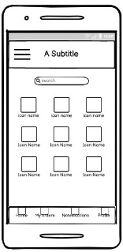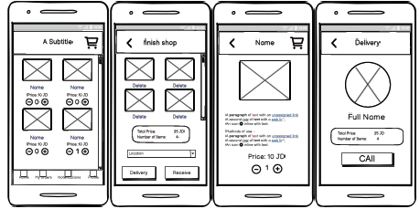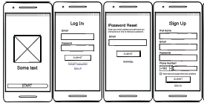

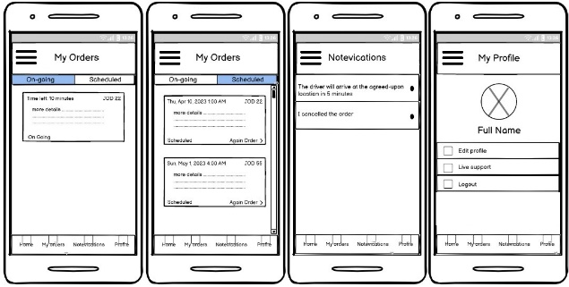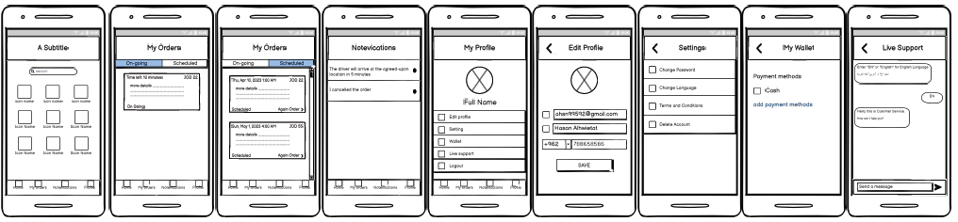

## 6.2 Iteration 1

### 6.2.1 Feedback – outline the end users’ feedback on the first iteration of your wireframe.

The notes came from users and stakeholders, and the notes were about the use of the home menu for each of the home page and each of the profile pages, my requests and notifications for the application, and the use of search also on the home page. All these problems needed to be changed. For example, we deleted the main menu and search for materials

## 6.3 iteration 2

### 6.3.1 Feedback – outline the end users’ feedback on the second iteration of your wireframe.

As for the notes that came after making the amendment to the initial model, some comments came about deleting the material page that displays the details of the products, because the product is known through the pictures and the name, and there is no need for it, and also adding some features on the profile page such as payment methods and settings, and also an amendment to the completion page from shopping that was not suitable for the user some modifications have been made

## 6.4 Screenshots after applying feedback (of the updated wireframes only)

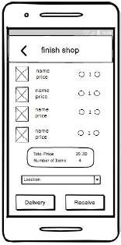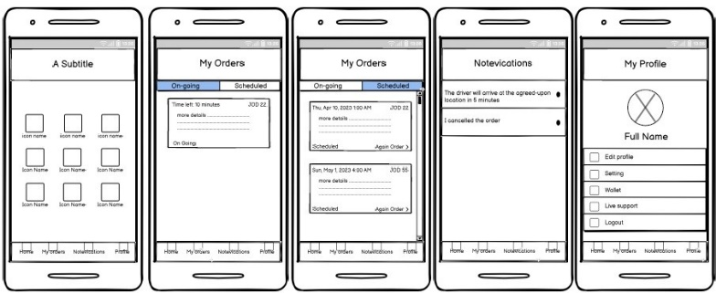

# **Mid-fidelity Mock-up**

## 7.1 Mockups screenshots before applying feedback.

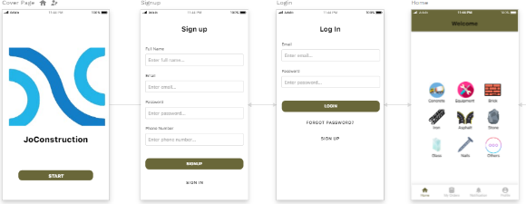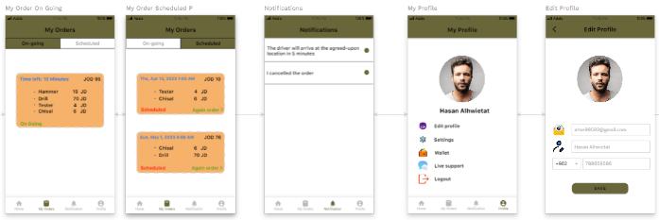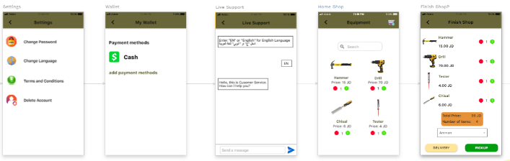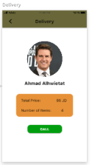

## 7.2 Iteration 1

### 7.2.1 Feedback - outline the end users’ feedback on the first iteration of your Mockup.

After the completion of the prototype of the Mockup, notes were taken from end users and stakeholders. The notes were on the logo for the application in the cover page, and also the use of some inappropriate words was addressed.

## 7.3 iteration 2

### 7.3.1 Feedback- - outline the end users’ feedback on the second iteration of your Mockup.

After completing the modifications to the prototype of Mockup, some notes were taken. The colors that were used in the application were inconsistent, uncomfortable for the eye, and caused problems for users.

## 7.4 Screenshots after applying feedback (of the updated mockups only).

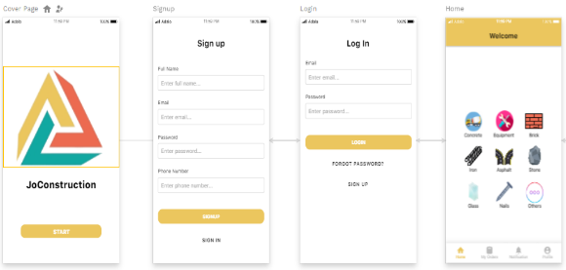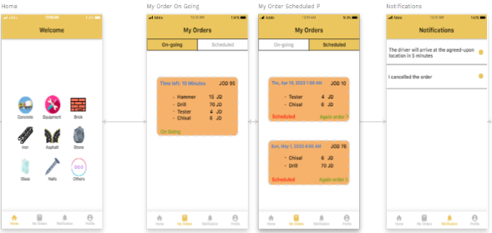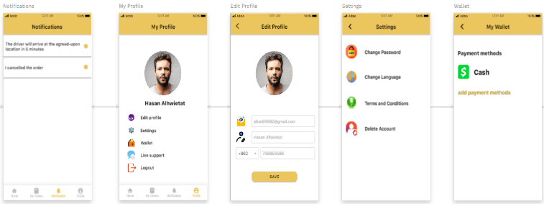

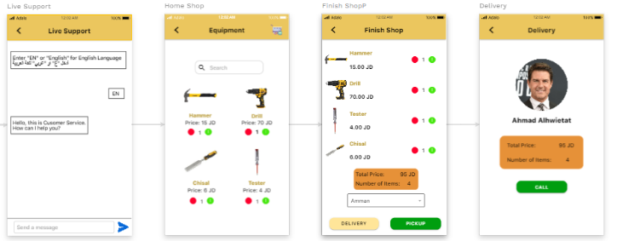

# **High-fidelity Prototype**

## 8.1 Outline the added features to build your high-fidelity prototype. (What are the interactions, validations added to your prototype to make it similar to the final product)

My application contains many features, interactions, and verification processes, for example, the application provides the service of logging in, creating a new account, forgetting about the account, providing the service for searching for materials, and providing interactions between the pages so that you can navigate between the pages correctly and the buttons all work, and you can also write in all the places that contain The text input also provides an idea of how to make a new order and add it to the shopping cart so that you can visualize the scenario that could happen.

## 8.2 Review end-user feedback from multiple iterations of your prototype and justify the updates to the final prototype based on end user feedback and testing.

There were many notes submitted by end users and stakeholders so that they were having problems navigating between pages and trying to discover some features that were not working normally and also some words were modified on the buttons that were incomprehensible and the name of the project was put in the cover page and it was done Amending the method of displaying the request data, and adjusting the sizes of images and fonts so that they fit the user experience better than before, and some features such as modifying the data from within the application, such as the name, number, and writing in the place of chatting, were used a lot of these notes to reach the high-resolution model that somewhat similar to the final product.

# **Critically evaluate the prototype against the original plan and how user feedback and testing was implemented.**

It is very important to evaluate the prototype against the original plan, take feedback from users and stakeholders, and implement testing to ensure the effectiveness and success of the project and that it meets the needs of end users and that the interface is comfortable and simple to improve the user experience. Since we need to evaluate how the prototypes relate to the original plan and how to implement and test user feedback.

The project has adhered to the original plan that was established since the start of the project, which was important to ensure the progress of work and its implementation to the fullest. and assess the reason for the difference that occurred.

It also helps how to evaluate the feedback and comments of end users and stakeholders in order to improve the prototype by identifying priorities and their impact on the system and evaluating improvements and new features that have been modified based on the feedback.

And since we used the evolutionary prototype methodology, which is subject to multiple iterations based on user feedback and tests, in each process the continuous improvement that occurs to the prototype is evaluated, so we saw at every stage of the design the low, medium and high accuracy prototype that the final prototype has improved A lot of modifications and features were added based on user feedback.

Also, the prototype is affected by evaluating the user's notes on the tests and how they affect the decisions of the prototype. In our project, all of the comments, notes and tests contributed to improving the quality of the final model.

Evaluation is important in all stages of development because it effectively helps to improve the user experience and user interface and helps to identify the stages that must be modified and improved after conducting tests for them and making sure that they need improvement and adding some features to that following the original specific plan ensures that the final model User centric, within the core objectives of the project and aligned with stakeholder expectations

# **References**

1. <https://www.reforge.com/blog/brief-the-4-different-types-of-product-prototypes>
2. <https://www.simplilearn.com/prototyping-in-design-thinking-article#:~:text=What%20are%20the%20different%20types,prototypes%20and%20live%2Ddata%20prototypes>.
3. <https://www.makeuseof.com/what-is-figma-used-for/>
4. <https://balsamiq.com/wireframes/desktop/docs/intro/#:~:text=Balsamiq%20Wireframes%20is%20a%20user,before%20any%20code%20is%20written>.
5. <https://www.sketch.com/docs/prototyping/>
6. <https://www.pendo.io/glossary/user-segmentation/>
7. <https://www.designabetterbusiness.tools/tools/persona-canvas>
8. <https://www.b2binternational.com/research/methods/faq/what-is-the-value-proposition-canvas/>
9. <https://blog.hubspot.com/service/customer-journey-map>
10. <https://www.optimove.com/resources/learning-center/customer-behavior-modeling>
11. <https://www.techtarget.com/searchcio/definition/Prototyping-Model#:~:text=The%20prototyping%20model%20is%20a,or%20product%20can%20be%20developed>.
12. <https://blog.hubspot.com/marketing/usability-testing>
13. <https://www.scribbr.com/methodology/focus-group/#:~:text=a%20focus%20group%3F-,A%20focus%20group%20is%20a%20research%20method%20that%20brings%20together,of%204%20types%20of%20interviews>.
14. <https://mockitt.wondershare.com/prototyping/evolutionary-prototyping.html>
15. <https://stackify.com/what-is-sdlc/>
16. <https://www.javatpoint.com/advantages-and-disadvantages-of-sdlc>